Direction of Arrival (DOA) algorithms are used for estimation of a number of incident plane waves on the antenna array and their incidence angles.

Direction-of-arrival (DOA) estimation refers to the process of retrieving the direction information of several electromagnetic waves/sources from the outputs of a number of receiving antennas that form a sensor array.

In signal processing, direction of arrival (DOA) denotes the direction from which usually a propagating wave arrives at a point, where usually a set of sensors are located. These set of sensors forms what is called a sensor array. Often there is the associated technique of beamforming which is estimating the signal from a given direction

A sensor array is a group of sensors, usually deployed in a certain geometry pattern, used for collecting and processing electromagnetic or acoustic signals

Fundamental parameters of linear frequency modulation (LFM) signals, i.e., the initial frequency and Chirp rate

Snapshots are no of samples in TD which aids in DOA estimation.

angular resolution is the minimum distance between two equally large targets at the same range which radar is able to distinguish and separate to each other.

The resolution however is both a product of mainlobe width and side lobe level.

T HE resolution of a beamformer represents its capability to separate two incoming plane waves arriving at different angles accurately, thus assessing how well sources can be distinguished.

Assume if there are two sources in space for which you want to find thier DOAs, then what will be the minimum separation between them so that you will be able to detect /find DOA of these sources without any ambiguity is called the resolution of the DOA algorithm.

 is the smallest angle between close objects that can be seen clearly to be separate

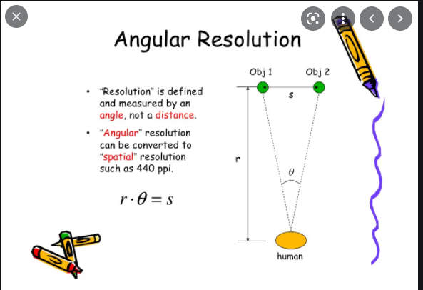

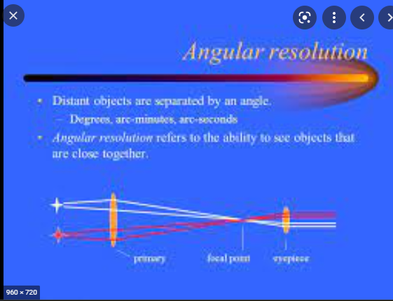

Actually, the MUSIC is essentially a noise-subspace-based algorithm, and its performance of DOA estimation mainly depends on the accuracy of the noise subspace. In the aforementioned researches, the noise subspace

Angular resolution refers to the ability to see objects that are close together

is formed by eigenvectors corresponding to all small eigenvalues of the array output covariance matrix [9]. However, after a thorough analysis we found that the estimation of DOA through the noise subspace in the traditional formation is not optimal in almost all cases, and using a partial noise subspace can always obtain better estimation results.

